Website Planning Document:

Keeping up with the currents

Motto: Weather it’s good or bad, we report it.

Author: Jalyn Zamora

Site Purpose:

The purpose of my website is for the user to be able to clearly identify the temperate and weather stories happening in their area. The goal is for them to understand and be able to depend on us for their current weather conditions.

Target Audience:

There will be a lot of people that will stumble upon the website. However, the website’s target audience are for teen and young adults. Most of them will visit the site when they need to get a quick peak at the weather and stories about what is happening around the city pertaining to weather.

Site Map:

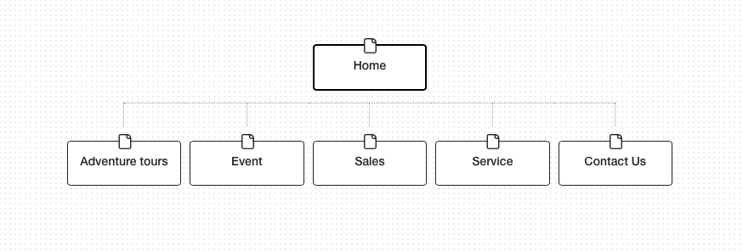

Color Scheme:

I chose this color scheme because I like the idea of having neutral colors for the website. The shades of green and blue give a hint of color to the website. I want the images on the website to pop, so have these simple yet appeal colors will bring the webpage to life.

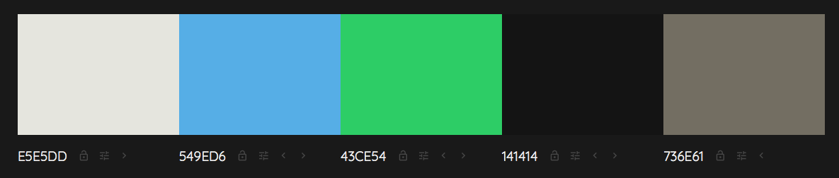

Typography:

For my titles and heading I’m going to use a sans serif type of font. I’ve added a couple of examples of the type of fonts I’m planning to use:

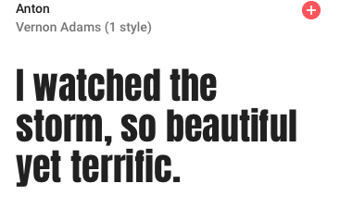 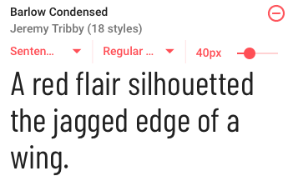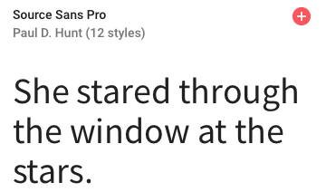

Wireframes:

Ipad, Desktop, Phone: <https://wireframe.cc/UXiPuI>

